Biodiversity In National Parks

Species Database

* **Category (Cateorical)** - class of animal
* **scientific_name (Categorical)** - the scientific name of each species
* **common_name (Categorical)** - the common names of each species
* **conservation_status** **(Categorical)** - each species’ current conservation status

Observations Database

* **scientific_name (Cateorical)** - the scientific name of each species
* **park_name (Categorical)** - Park where species were found
* **observations (Numerical)** - the number of times each species was observed at park

Species Summary

We own up to 5824 rows of data within this database. The most spotted category of all 7 categories ('Mammal', 'Bird', 'Reptile', 'Amphibian', 'Fish', 'Vascular Plant', 'Nonvascular Plant') Vascular plant makes up 4470 rows of data. The least shown category being Reptilians. The most spotted Conservation was ‘Species of Concern’ making up 160 rows of data.

Observations

We own up to 23296 rows of data within this database. On average a species is spotted 142.3 times amongst all listed parks. With a standard deviation of 69.9. The standard deviation (69.9) is relatively large compared to the mean (142.3), which suggests there could be considerable variability in the data. If the data follows a normal distribution, we would expect to see a spread of sightings that is roughly symmetric around the mean. The parks used for observations are Great Smoky Mountains National Park, Yosemite National Park, Bryce National Park, Yellowstone National Park. All of which make up 5824 rows of data each.

Number of Animal Observations by Class in Each Park

Overall Yellowstone National Park has the most variety of different species, whilst Great Smoky Mountains National Park possesses the least variety of species. Vascular Plants are the most spotted across all parks followed by Birds. The least commonly spotted species seem to be both Reptilians and Fish.

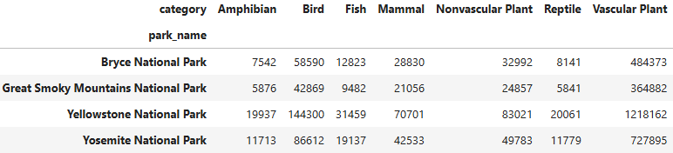

Number of Animal Observations by Conservation

As expected, Species of Concern is the most spotted category, majority of which is made up from Birds, Mammals, and Vascular Plants. The most endangered species are Mammals. Birds are the most seen species in recovery. Fish are the most threatened when it comes to endangered.

